Challenge Problems #1

1) Give an example of a realistic source of data for which the relational model doesn't work very well. Note that this question is about structuring data, not computing things. Thus, responses like "you can't compute n! in the relational model" or "you can't simulate a Turing machine" are not appropriate answers.

2)
Suppose we have a relation Employees(name, department, salary). For each of the following queries, either write the query in relational algebra and explain informally why your answer works, or explain why it cannot be written in relational algebra. You may use sequences of assignments or expression trees if you like. You may use only the following operators of relational algebra: union, intersection, difference, selection, projection, products, joins (theta and natural), renaming.

- Find all department(s) with at least two employees of different names.
- Find the department(s) with the most people.
- Find the names of employee(s) with the highest salary.

Challenge Problems #2

1) Recently in class, we covered the term "ACID" as an acronym for four concepts that guarantee database transactions are processed reliably. This term was coined by Haerder and Reuter in early 80s. As a 21st-century transaction-processing enthusiast, come up with a new acronym for the same four fundamental concepts. Change at least three of the original words used in spelling the term ACID. Choose words that convey the four concepts more clearly, while ensuring their initials spell out a meaningful word. There is no constraint on how you order the initials of the four terms. Meanwhile, consider the possibility of fame and fortune if your acronym is approved for publication in ACM Transactions on Database Systems, and thus refrain from using inappropriate words.

2) Consider the four queries given below. Give an example of a database that guarantees two of the queries return only one tuple, and the other two return two tuples. Give the relations in your database, as well as the resulting tuples for each query. Include an explanation of how you reached your result in all four queries.
a) SELECT A.X
FROM A NATURAL JOIN B
WHERE A.X NOT IN (SELECT A1.X
FROM A A1
WHERE A1.Y = 1)

b) SELECT B.Y FROM B
WHERE B.Z > ALL (SELECT B1.Z
FROM B B1
WHERE B1.Z > B.Z)

c) SELECT DISTINCT A.X, SUM(B.Z)
FROM A, B
WHERE A.Y=B.Y
GROUP BY A.X
HAVING COUNT(B.Z) > 1

d) SELECT A.X
FROM A NATURAL JOIN B
UNION
SELECT A1.X
FROM A A1
WHERE A1.Y < 6

Challenge Problems #3
Imagine you own all the bars in San Francisco (you are rich!) and you have the following tables in your database to manage them (read carefully):
i) Bars(Name, Address, Drunk_Capacity, Status)
ii) Drinkers(Name, Phone, Address, Tolerance)
iii) Drinks(Name, Bar_Name, Drinker_Name, Power)
iv) Cabs(Drinker_Name, Start_Address, End_Address)
Here are the rules that govern this world:
1) Bars.Status can take on only two values “OPEN” or “CLOSED”. We can open or close our bars with this field.
2) Drinkers.Tolerance is simply an integer number from 0-10.
3) Drinks.Power is also an integer indicating the strength of the drink.
4) Anytime a drinker orders a drink, an entry gets added to the “Drinks” table.
5) If the total of Drinks’ Power for a particular drinker, gets passed the drinker’s tolerance level, then he or she is “OFFICIALLY DRUNK”
6) Bars.Drunk_Capacity signifies how many drunks a bar’s security team can handle.
7) Anytime you want to send a drunk home, you add an entry to the “Cabs” table to send him/her home from the Bar.
Question 1: If we have too many people that are officially drunk in a bar, we have to close the bar; otherwise the bar has to be open. Write an ASSERTION to maintain this constraint (3pts).
Question 2: If a bar gets shut down because it has too many drunks, then we have to send people home. Write a trigger that calls a cab for the drunks (be careful when you want this trigger to be executed, think simple!) (3pts).

Challenge Problems #4
As I was going to Saint Ives, I met a man with 7 wives.
Every wife had 7 sacks; every sack had 7 cats.
Every cat had 7 kits.
Kits, cats, sacks, wives,
How many were going to Saint Ives?
Bonus question (0pts):
How many were going to Saint Ives? (This question is just for laughs! We don't want to see any emails about this one!)
Hint: that the answer is not 2800!
Real Questions:
Question 1.A) Describe an XML Schema document with this structure, assuming the man, the wives, sacks, cats, and kits all have names that are attributes, and the nested structure that is described by the rhyme holds. (4pts)
Question 1.B) Describe the same document structure with a DTD. (4pts).
Given some FD's, a set of attributes X is closed if X+ = X. That is, each given FD either does not have its left side contained in X, or it also has its right side contained in X. The empty set and the set of all attributes are always closed. The other closed sets uniquely determine the FD's.
Question 2.A) Suppose there is some set of FD's for a relation with schema ABCD, and the only closed set (besides the empty set and ABCD) is AB. What are the FD's? (3pts)
Question 2.B) Explain briefly why AB is closed, and no other set is, for your chosen FD's. (3pts)
Question 3.A) Consider a relation R(A,B,C). Write a relational algebra expression that returns an empty result if and only if the multivalued dependency A ->-> B holds on R. Use only the standard relational algebra operators. (3pts)
Question 4.A) Prove that every 2-attribute relation is in BCNF. (3pts)

Challenge Problems #5
Question 1: Consider a relation R(A,B,C,D,E). Prove that A->->B and BC->->D imply AC->->D, using the tableau method.
Question 2: Consider the ER model in Fig 2.1 (attached) for a video store database. For each movie, the database contains information about title, producer-name, director-name and characters in the movie. For each character in the movie, it contains the character-name and the name of the actor/actress who played the character. (Note: characters in different movies with the same name, e.g., James Bond, are considered different characters.) The movie videos may be available at the store in VHS or DVD format. Different formats may have different prices. DVD format also comes with subtitle options. The attribute Num-subtitles indicates the number of subtitle language options available in the DVD.
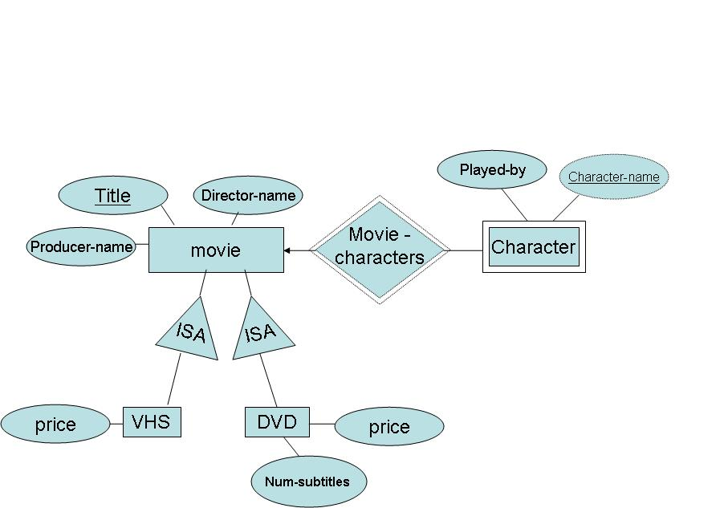
Create a relational database schema for this model assuming
2.A) Each movie in the database is available at the store in exactly one of the two formats - VHS or DVD. (2pts)
2.B) Some movies in the database may not be available at the store and others may be present in both the formats.(2pts)
Provide the name of the table, primary key, and other attributes for each table in your solution. Think intelligently between various choices available to you, including those not mentioned explicitly in the class discussion of translating E/R to relations, to get best design for the problem in hand. Minimize the use of NULLs. Your representation will be evaluated based on correctness and succinctness.
Question 3: Consider the following relational database
employee(person-name, street, city)
manages(person-name, manager-name)
Write A Datalog program to find all pairs of distinct employees who live in the same city and have a common manager anywhere in the company hierarchy. Note that, in contrast with the "cousins" example in class, the employees may not be the same number of levels down the hierarchy.

